Question 1.
Given $a,b$ are two positive real numbers satisfying $a+b=1$ and $a^{3}+2b^{3}=3ab^{2}.$
Calculate the value of the expression
$$P=\frac{a+4b}{3a^{2}+2b^{2}}$$
Question 2.
An participates in a Math exam including 30 questions, where each correct answer gets 6 points, each incorrect answer loses 2 points, and unanswered questions get 0 points. After finishing, An's total score is 52 points, and it is known that An has at least one unanswered question and the number of questions An answered accounts for more than 75% of the total questions. How many questions did An not answer?

Question 3.
Given the expression $f\left(x\right)=(x^{3}-5x)^{10}.$ Calculate the value of $f\left(1-\sqrt{2}\right)$
Question 4.
Consider positive integers $x,y$satisfying $x^{2}-y^{2}=240$. When $x-y$ reaches the minimum value, calculate the value of $x^{2}+y^{2}.$
Question 5.
Fill consecutive even positive integers in rows as shown in the figure below. The n-th row has exactly $3n$ numbers filled. What is the last number (from left to right) of the 10th row (from top to bottom)?

$$\begin{matrix}2 & 4 & 6 & & & & & & & \\ 8 & 10 & 12 & 14 & 16 & 18 & & & & \\ 20 & 22 & 24 & ⋯ & 36 & & & & & \\ ⋯ & & & & & & & & & \end{matrix}$$

Question 6.
Given a triangle ABC with $BC=4\sqrt{7} cm, góc BAC=60° .$ A circle with center O touches the two lines AB and AC and at the same time the center O lies on the segment BC. Given that $OC=3OB,$ calculate the length of side AC. (Unit: cm)
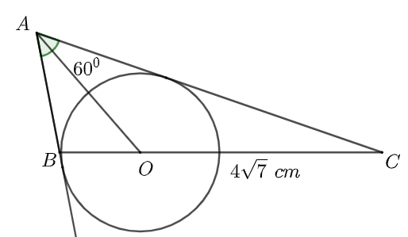

Question 7.
Given the sequence $\left(x_{n}\right)$ defined by $x_{1}=1$ and $x_{n+1}=\frac{\sqrt{4x_{n}^{2}+1}}{2}.$
Calculate the value of $S=\sum_{k=1}^{50}{\left\lfloor {\left(\frac{2}{x_{k}x_{k+1}}\right)}^{2}\right\rfloor }.$
For a real number x, the symbol $\left\lfloor x\right\rfloor$ denotes the greatest integer not exceeding x.

Question 8.
Given a polynomial $P(x)$ with real coefficients satisfying

$$P(x^{2} - x) + 2P(x^{2} + x) = 3(x^{2} + x + 1) ∀x ∈ R$$

Calculate the value of $S=P(1)+P(2)+⋯+P(10)$

Question 9.
There are three boxes, each box contains 5 marbles and on each marble, we write a natural number belonging to the set S. The numbers filled must simultaneously satisfy the following two conditions:
i) Each marble in the same box is filled with exactly one number and no two marbles in the box are filled with the same number.
ii) For any two boxes, the number of marbles filled with the same number between those two boxes does not exceed 1. How many numbers must the set S have at least?
Question 10.
At each vertex of a cube ABCD.EFGH we fill a natural number belonging to the set $\left\{1;2;3;...;8\right\}$ (each number is filled exactly once). How many ways are there to fill such that the sum of the two numbers filled at each pair of opposite vertices of the cube are equal? (Two vertices of a cube are called opposite if they do not lie on the same face of the cube. For example, A and G are pairs of opposite vertices.)
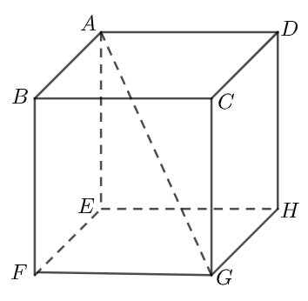

Question 11.
Let S be the set of positive integers n such that each digit of n is taken from the set $\left\{2;4;5\right\}$ and the sum of the digits of each number belonging to set S equals 16. How many elements does the set S have?

Question 12.
Given the right trapezoid ABCD with $\hat{A} = \hat{B} = {90}^{0} , AB = BC = 20 cm$. It is known that the circle with diameter AB touches the side CD (refer to the figure). Calculate the length of side CD (unit: cm)
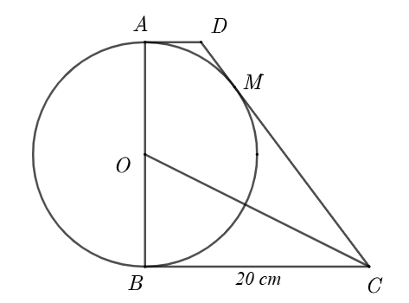

Question 13.
Find the smallest perfect square x with three digits such that x can be represented in the form
$x=7n+28m$, where $m,n$ are positive integers.

Question 14.
It is known that there exists a unique pair of integers $(p,q)$ such that
$(p-2)\sqrt{p^{2}+16}=3q+7.$ Calculate the value of $\left|p\right|+\left|q\right|.$

Question 15.
There are two boxes of candy, each box contains N candies. It is known that $N≤20$ and if 1 candy is taken from one of the two boxes, the total remaining candy in both boxes is divisible by 5 and 7.
Calculate N.
Question 16.
The number of notebooks sold at a stationery store on 7 consecutive days, from Monday to Sunday, are 26, 33, 20, 45, 38, 29 and x (unit: notebooks), respectively. It is known that the arithmetic mean and the median of these 7 data points are equal, and at the same time the number of notebooks sold on Sunday is greater than on Monday. Find the value of x.

Question 17.
For a positive integer n, the symbol $u(n)$ is the natural number formed by writing consecutive positive integers from 1 to n. Example: $u(1)=1,u(2)=12,u(3)=123,...,u(10)=12345678910.$
Find the remainder when $S=u(2)+u(4)+u(6)+⋯+u(100)$ is divided by 4.

Question 18.
Suppose a and b are two positive integers satisfying two conditions simultaneously: The sum of the two numbers a, b equals 110 and the difference between the Least Common Multiple and the Greatest Common Divisor of the two numbers a, b equals 520. Calculate $\left|a-b\right|.$

Question 19.
Given a trapezoid ABCD with $AD∥BC,$ Let N be the midpoint of side CD. A line passing through N intersects side AB at M such that the ratio of the areas of the two quadrilaterals AMND and MBCN equals $\frac{7}{9}.$ Calculate the length of the segment AM (Unit: cm)
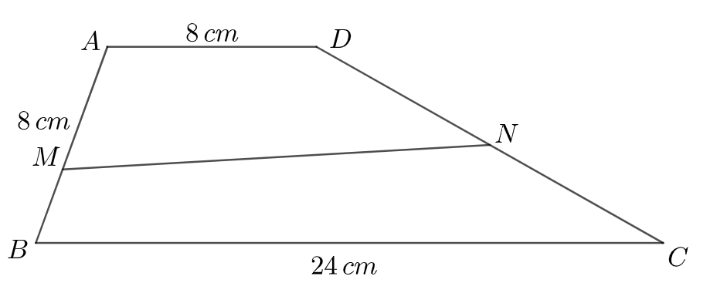

Question 20.
To log into an old website, Quan needs to correctly enter a four-digit password. However, because it has not been used for a long time, Quan has forgotten the password. Quan only remembers that the password has the form $\overline{6XYZ}$ with $X,Y,Z$ being three digits satisfying $1≤X≤Y≤Z≤6$ and the sum of the reciprocals of the four digits in the password equals $\frac{3}{4}.$ What is the correct password so Quan can log into that website?

Question 21.
Given a rectangle ABCD with Let M be the midpoint of AB and H be the projection of D onto MC. It is known that $sin\hat{DAH} = \frac{a}{b}$ (with a, b being two positive, relatively prime integers). Calculate $a+b.$

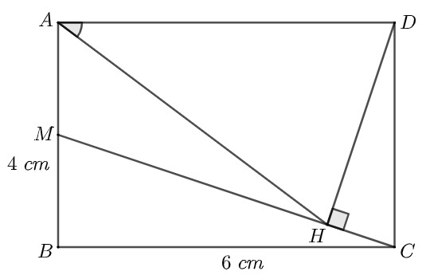
Question 22.
Let S be the set of natural numbers with four digits such that each of its digits belongs to the set $\left\{1;2;3\right\}.$ Randomly choose a number belonging to set S. The probability of choosing a number whose sum of digits equals 9 is $\frac{a}{b}$ (with a, b being two positive, relatively prime integers).
Calculate $a+b.$

Question 23.
Find the largest natural number n such that the value of $S=1+2+⋯+n$ is a natural number with four digits of the form $\overline{ABAB}.$

Question 24.
How many tuples $\left(A,B,C,D\right)$ are there in total, with $A,B,C,D$ being numbers belonging to the set $\left\{0;1;2;…;10\right\}$ satisfying $A.9^{3}+B.9^{2}+C.9+D=2025?$

Question 25.
A billboard has a rectangular shape ABCD with the length = 96 dm and the diagonal length is twice the width. The billboard is divided into two parts as shown, where the shaded part is bounded by the side BC, the circular arc BE which is part of the circle with diameter BC, the segment EF with point E being the intersection of the circle with diameter BC and the diagonal BD, point F belonging to side CD such that EF is perpendicular to CD. It is known that the area of the shaded part equals $Aπ+B\sqrt{3}$ (unit ), where A and B are positive integers. Calculate the value of $A+B$.
